Closed Curves

Definition
# Source: AI Source: Provided by: [Data Path: Persons Table -> ID Column: 1, Name_En Column: Motasem Essam] -> From: [ChatGPT] on [7/25/2026]
A closed curve is a curve in a plane that returns to its starting point, forming a continuous closed boundary with no endpoints.
$$\boxed{\text{Closed Curve}=\text{Continuous Curve that Returns to Its Starting Point}}$$
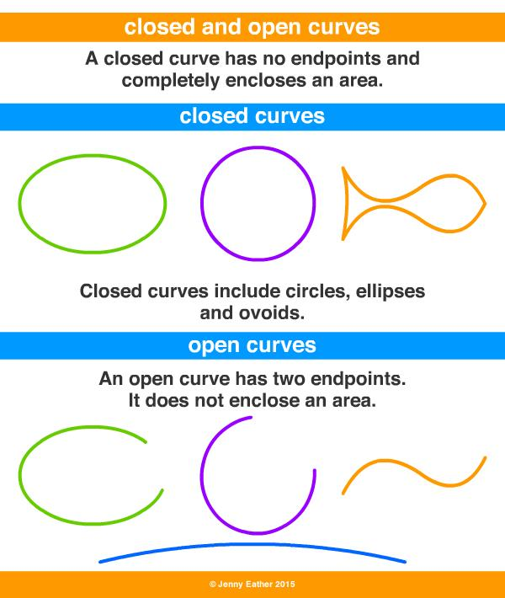
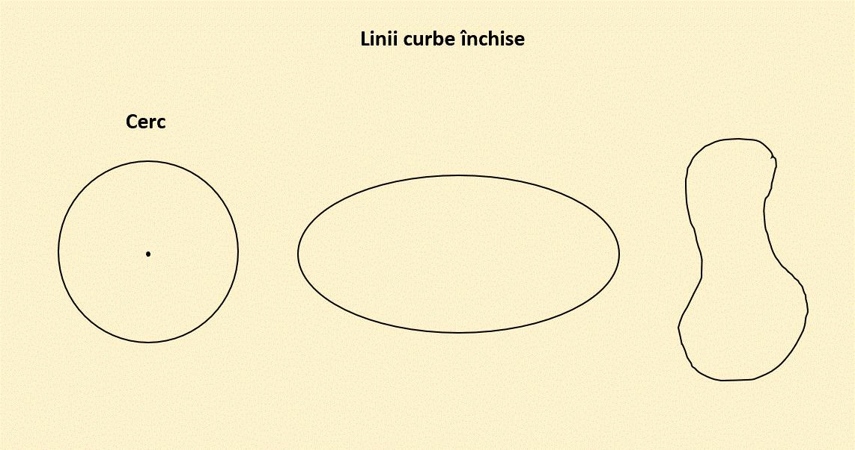
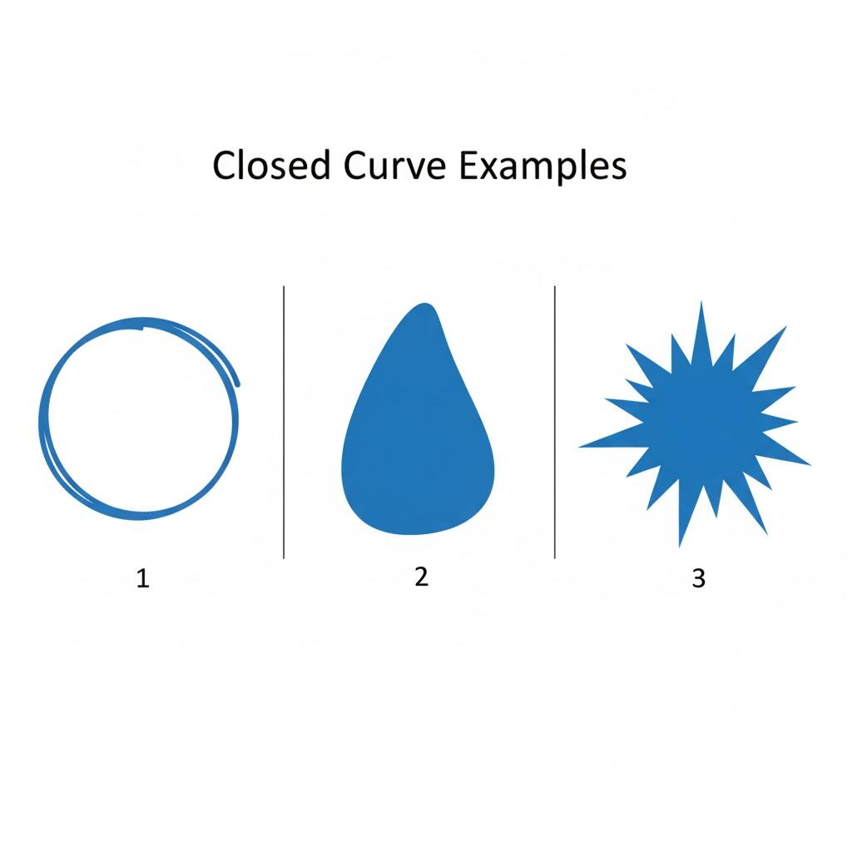
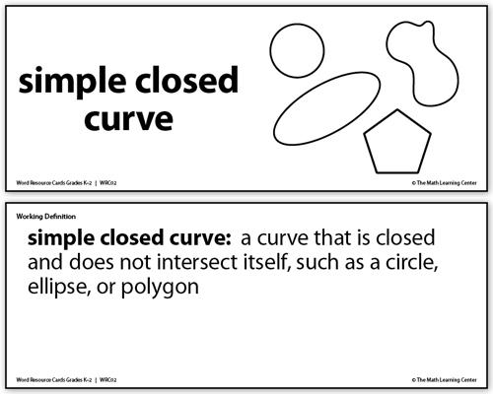
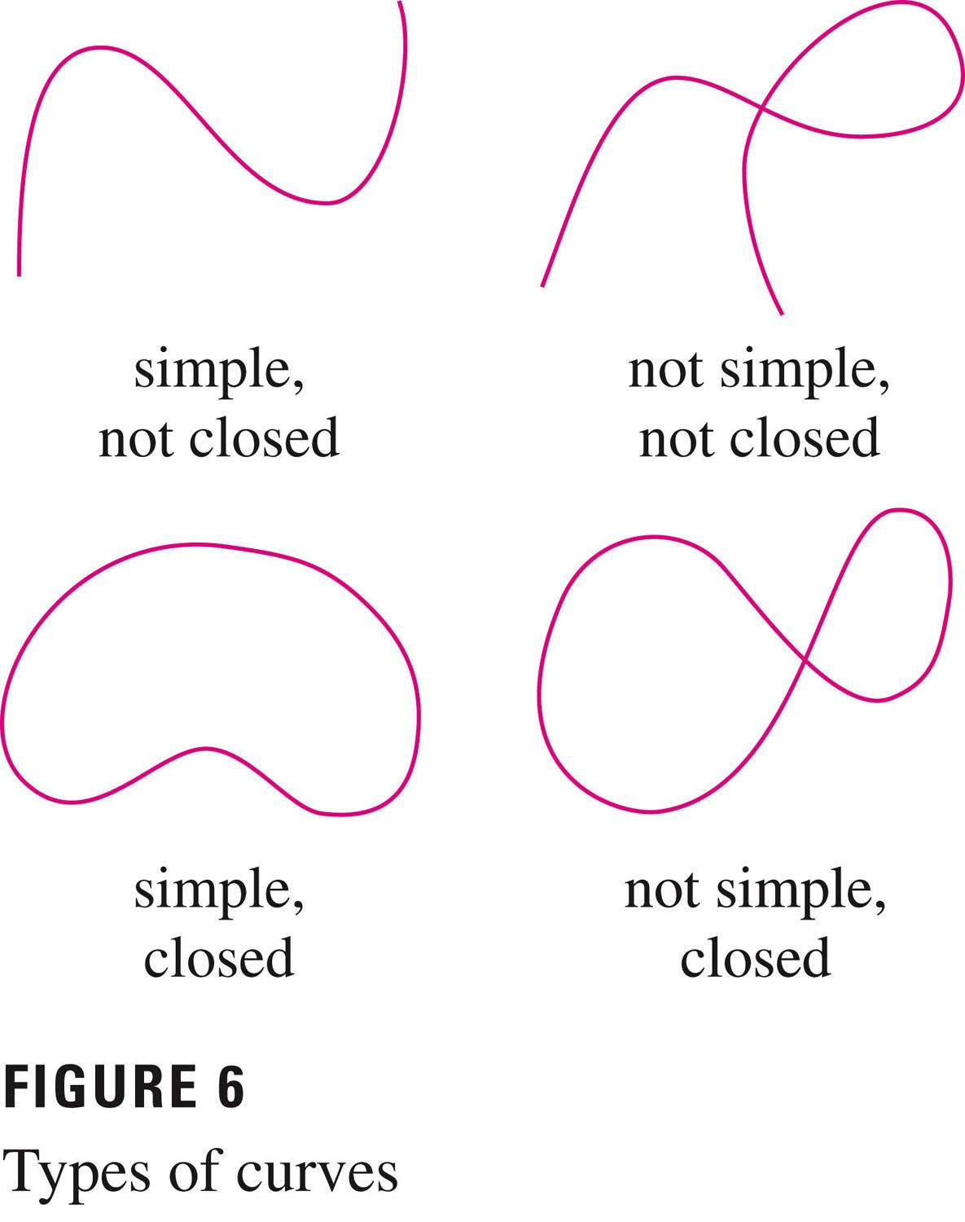

Types of Closed Curves

1. Circular Closed Curves
# Source: AI Source: Provided by: [Data Path: Persons Table -> ID Column: 1, Name_En Column: Motasem Essam] -> From: [ChatGPT] on [7/25/2026]
A circular closed curve is a complete circle in which every point is the same distance from a fixed center.
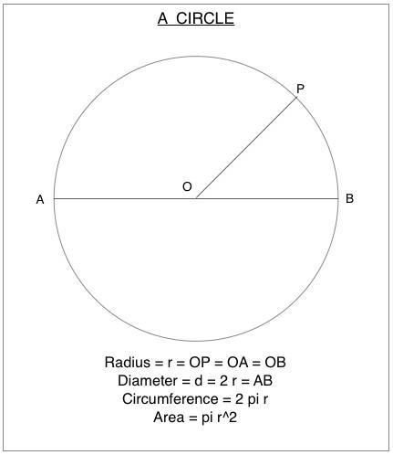
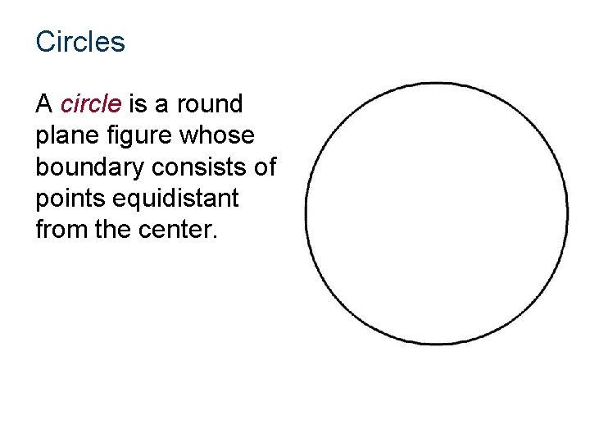
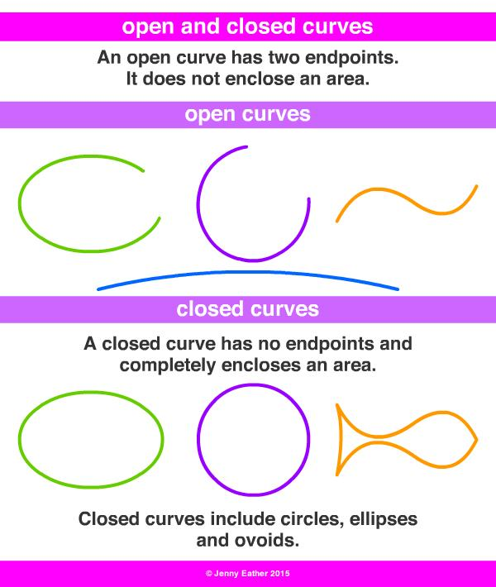
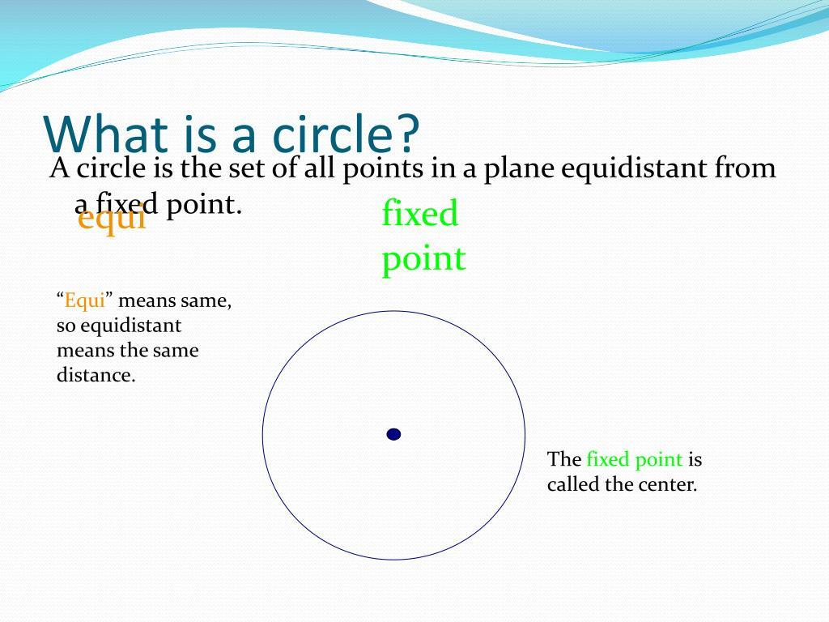
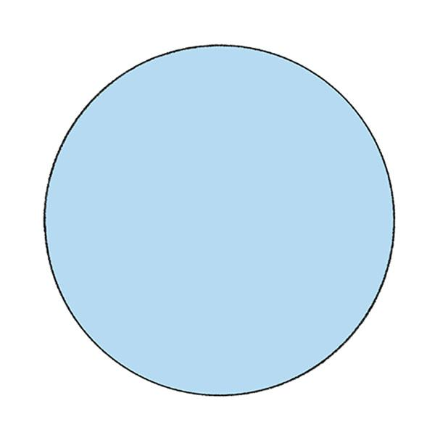
Key points:
- Completely closed.
- Has no endpoints.
- Has a constant radius.
- Has a center.
- Has rotational symmetry.

2. Elliptical Closed Curves
# Source: AI Source: Provided by: [Data Path: Persons Table -> ID Column: 1, Name_En Column: Motasem Essam] -> From: [ChatGPT] on [7/25/2026]
An elliptical closed curve is a complete ellipse.
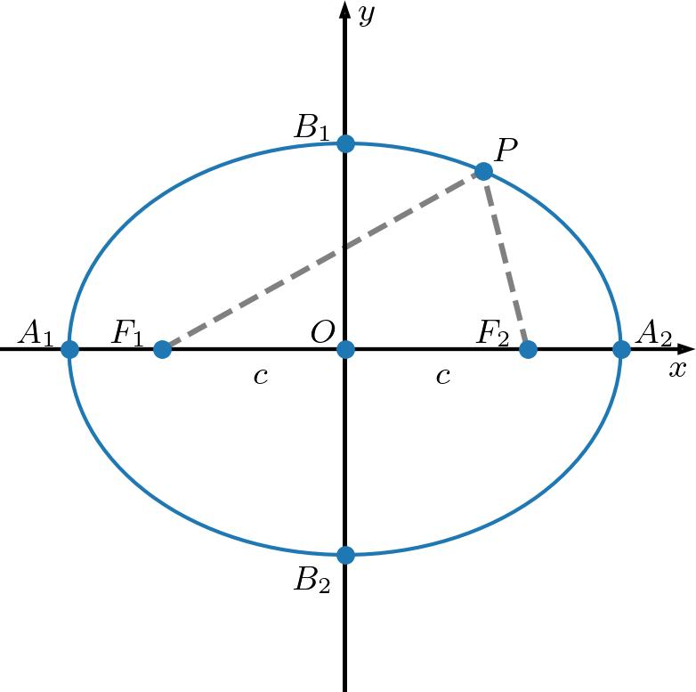
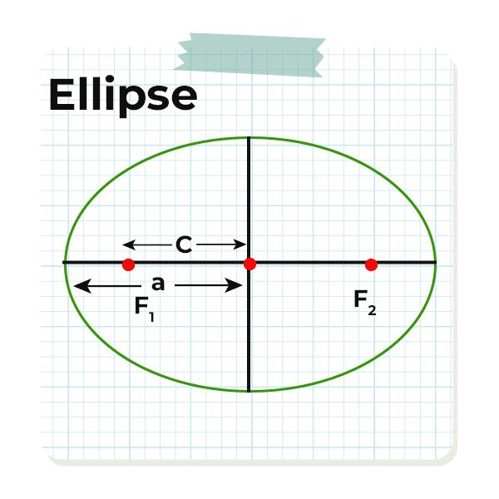
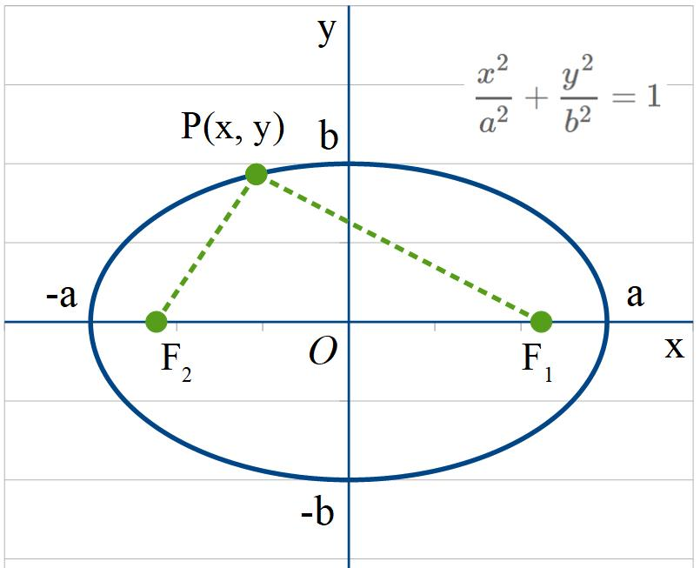
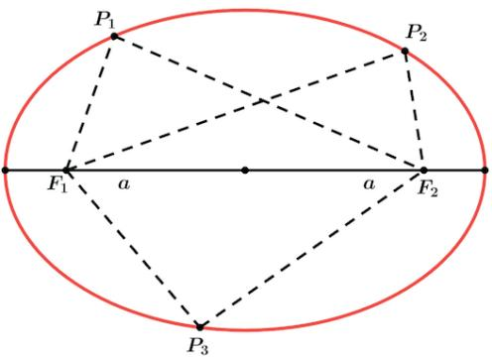
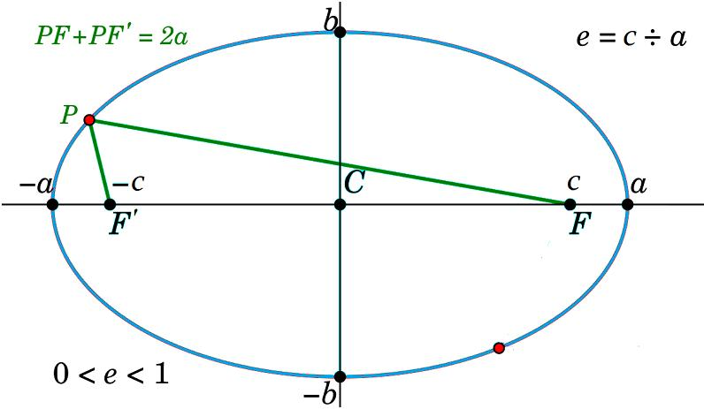
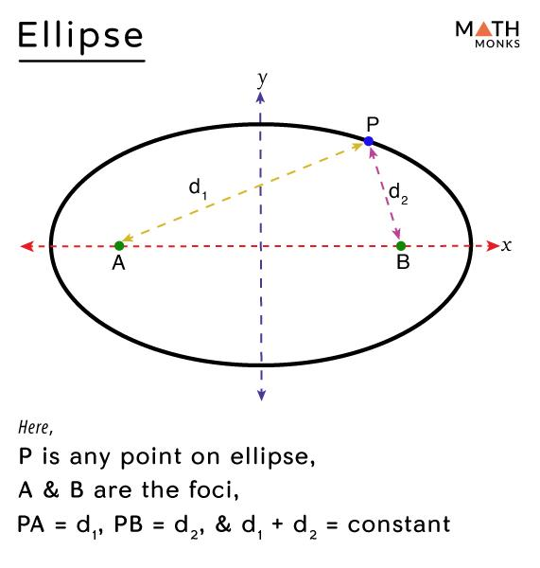
Key points:
- Closed.
- Has two foci.
- Usually has two axes of symmetry.
- Its curvature changes around the boundary.

3. Oval Closed Curves
# Source: AI Source: Provided by: [Data Path: Persons Table -> ID Column: 1, Name_En Column: Motasem Essam] -> From: [ChatGPT] on [7/25/2026]
An oval closed curve is a closed, elongated rounded shape that resembles an ellipse but does not necessarily follow the exact mathematical definition of an ellipse.
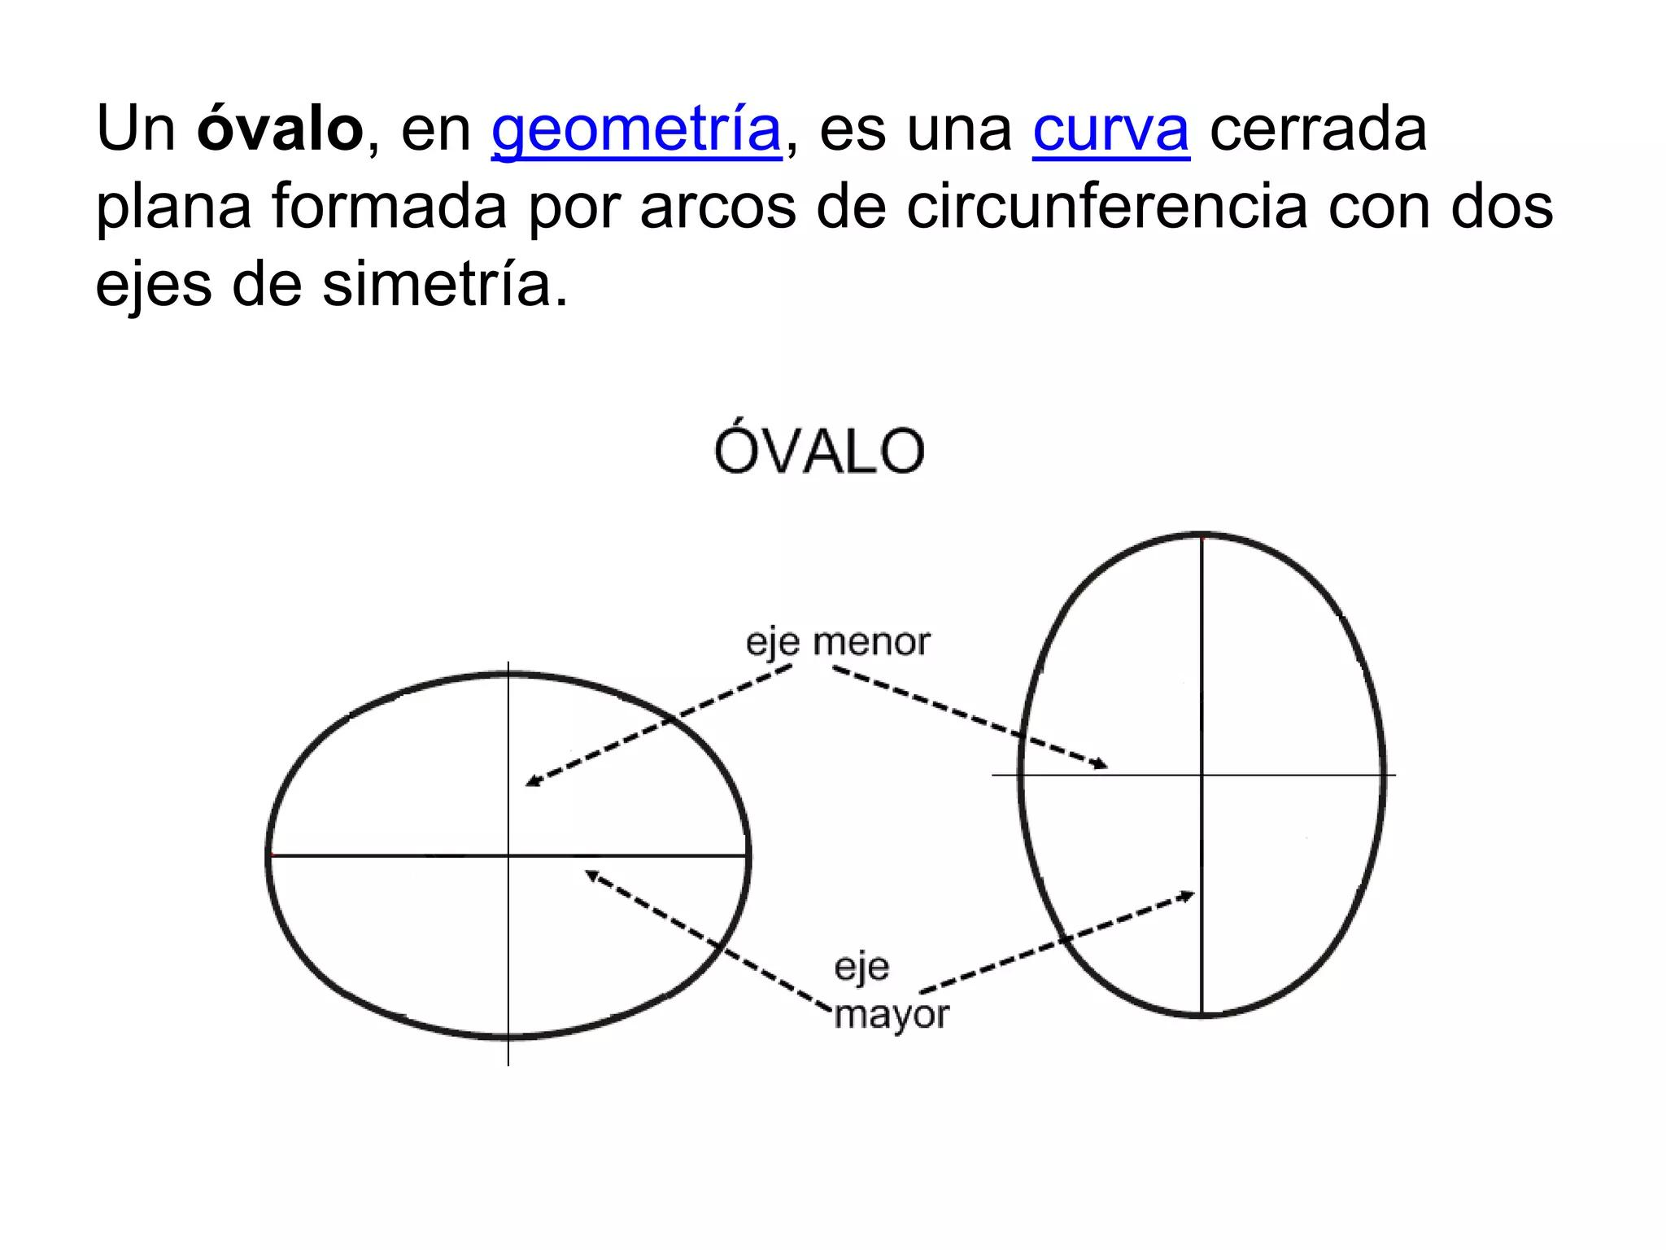
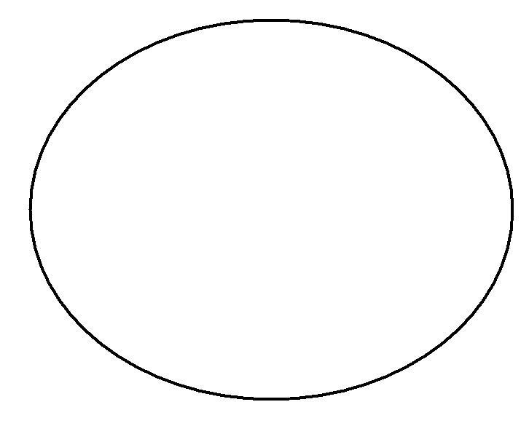
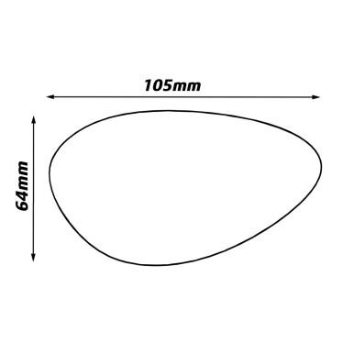
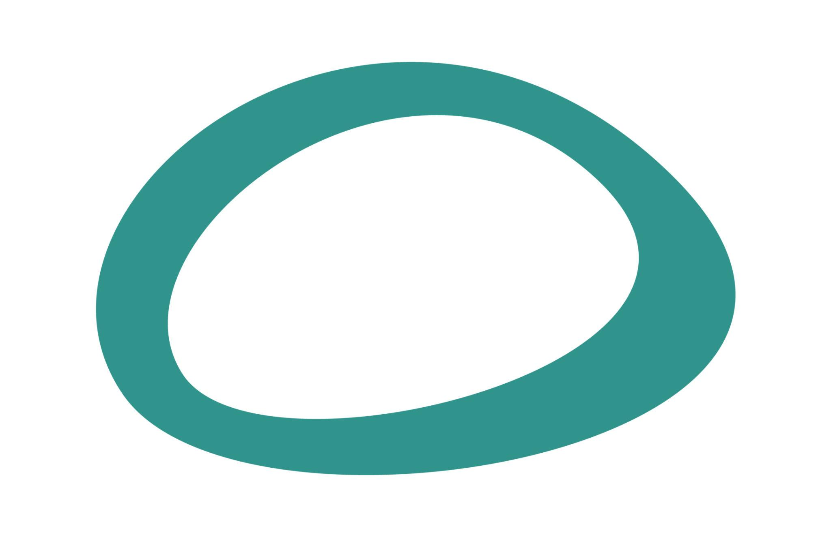
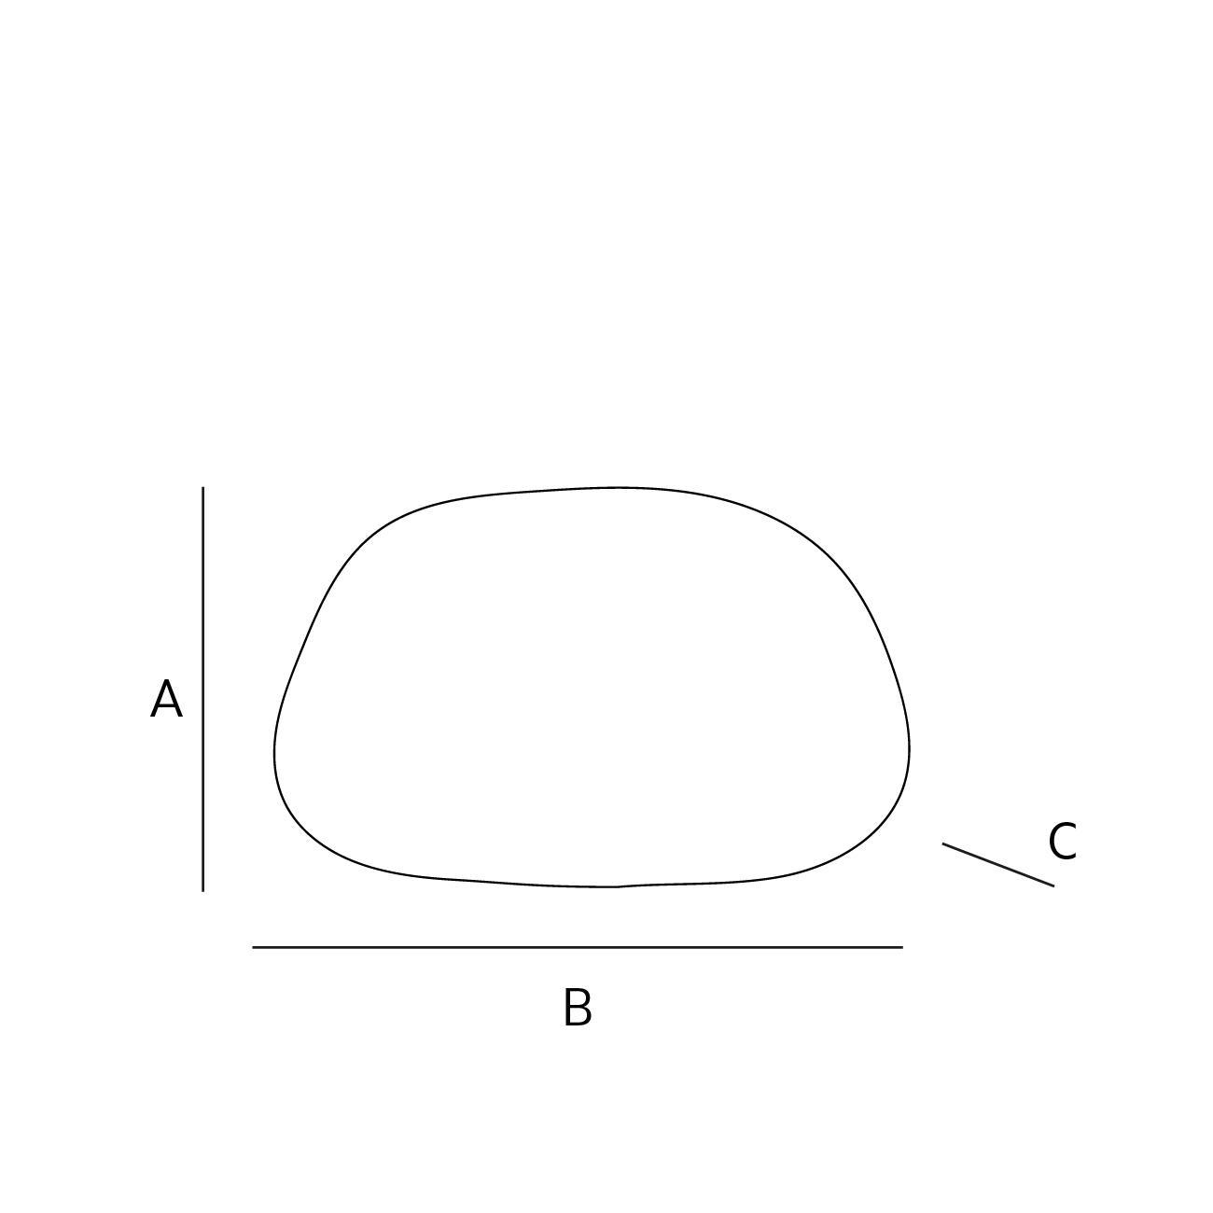

4. Organic Closed Curves
# Source: AI Source: Provided by: [Data Path: Persons Table -> ID Column: 1, Name_En Column: Motasem Essam] -> From: [ChatGPT] on [7/25/2026]
An organic closed curve has a smooth, natural-looking, irregular boundary.
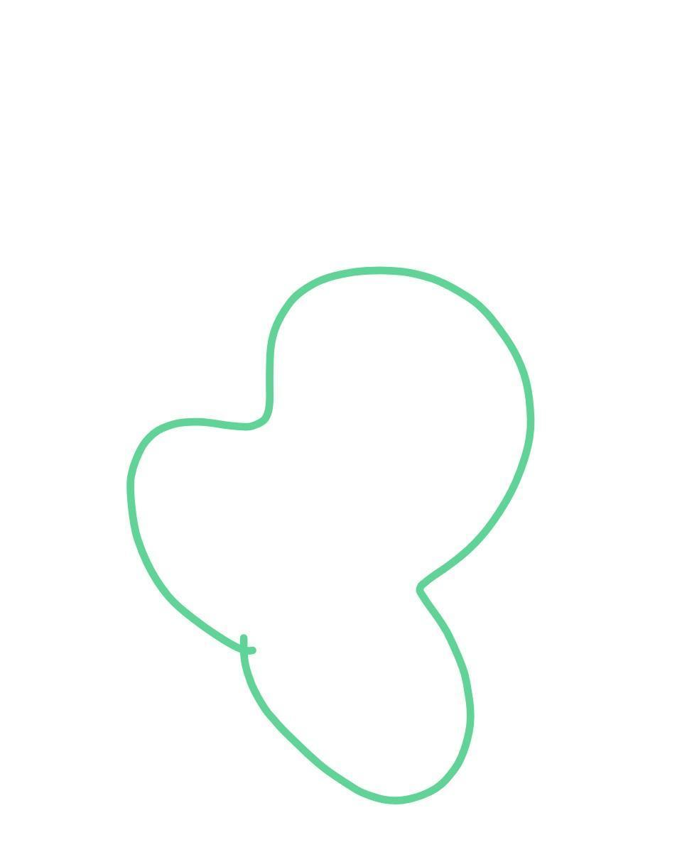
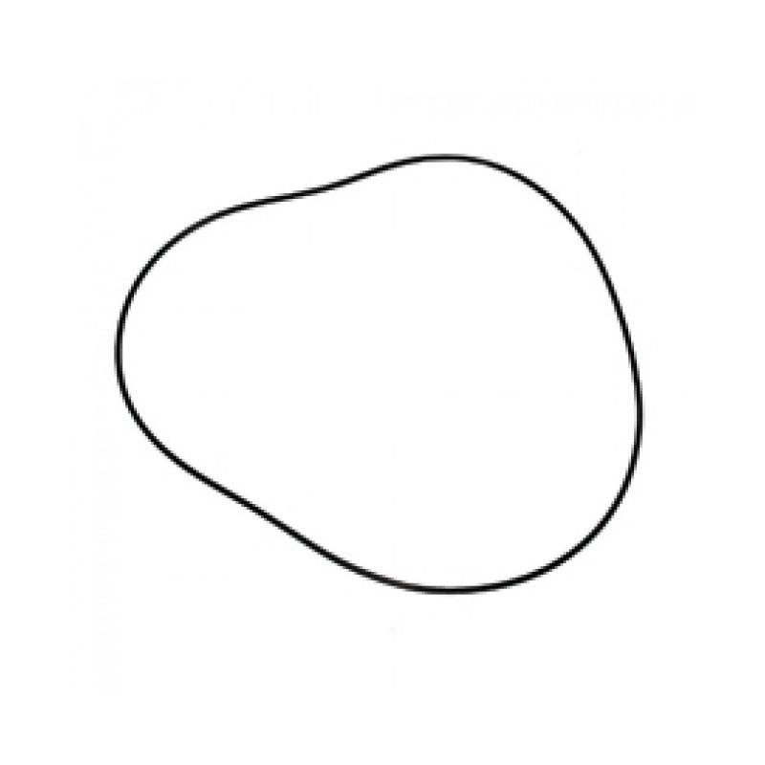
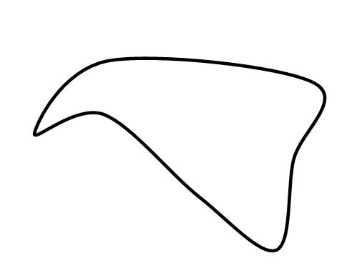
Examples may resemble:
- Leaves
- Stones
- Cells
- Natural puddles
- Organic objects

5. Freeform Closed Curves
# Source: AI Source: Provided by: [Data Path: Persons Table -> ID Column: 1, Name_En Column: Motasem Essam] -> From: [ChatGPT] on [7/25/2026]
A freeform closed curve is a closed boundary that is freely designed without following a standard geometric form.
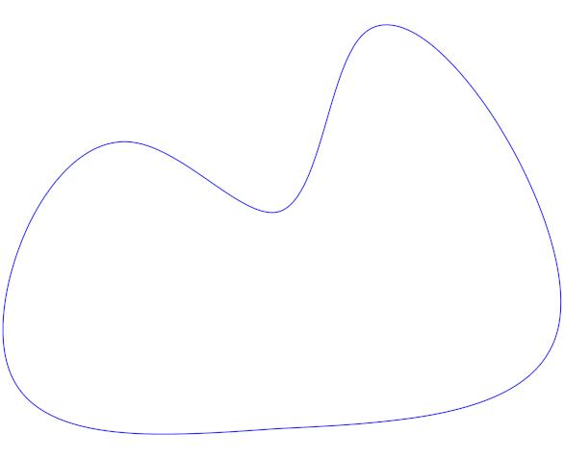
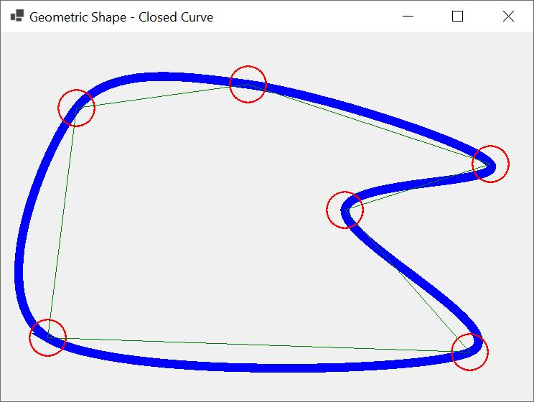
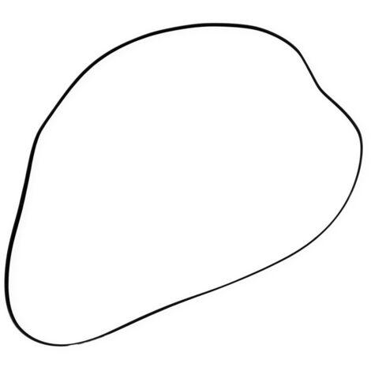
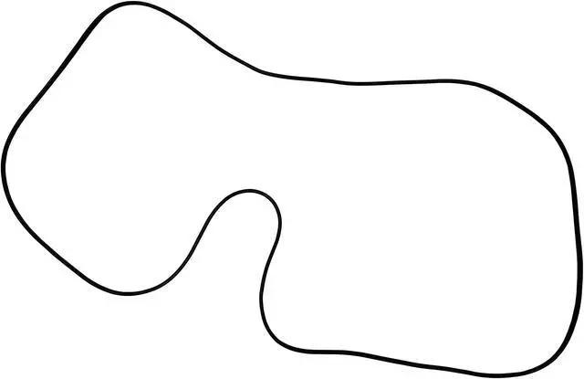

6. Wavy Closed Curves
# Source: AI Source: Provided by: [Data Path: Persons Table -> ID Column: 1, Name_En Column: Motasem Essam] -> From: [ChatGPT] on [7/25/2026]
A wavy closed curve has repeated or irregular undulations while eventually returning to its starting point.
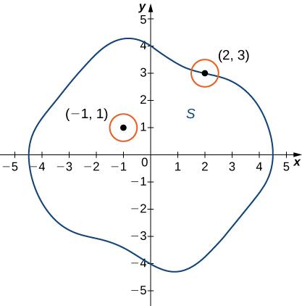
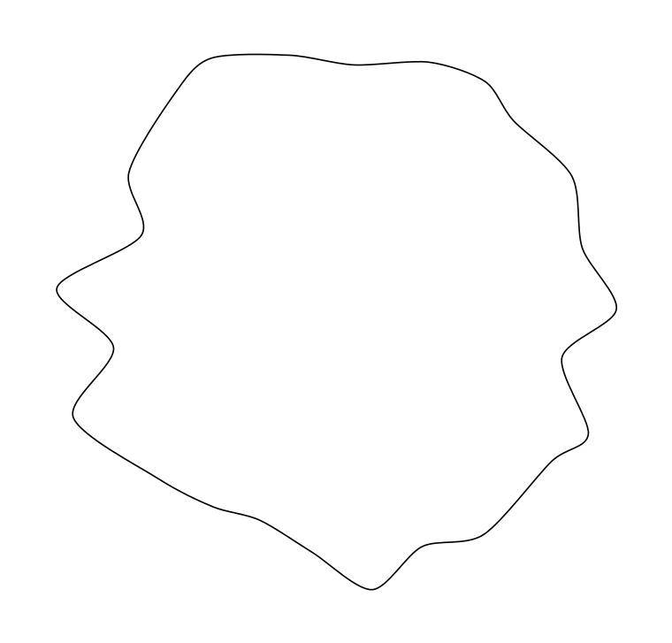
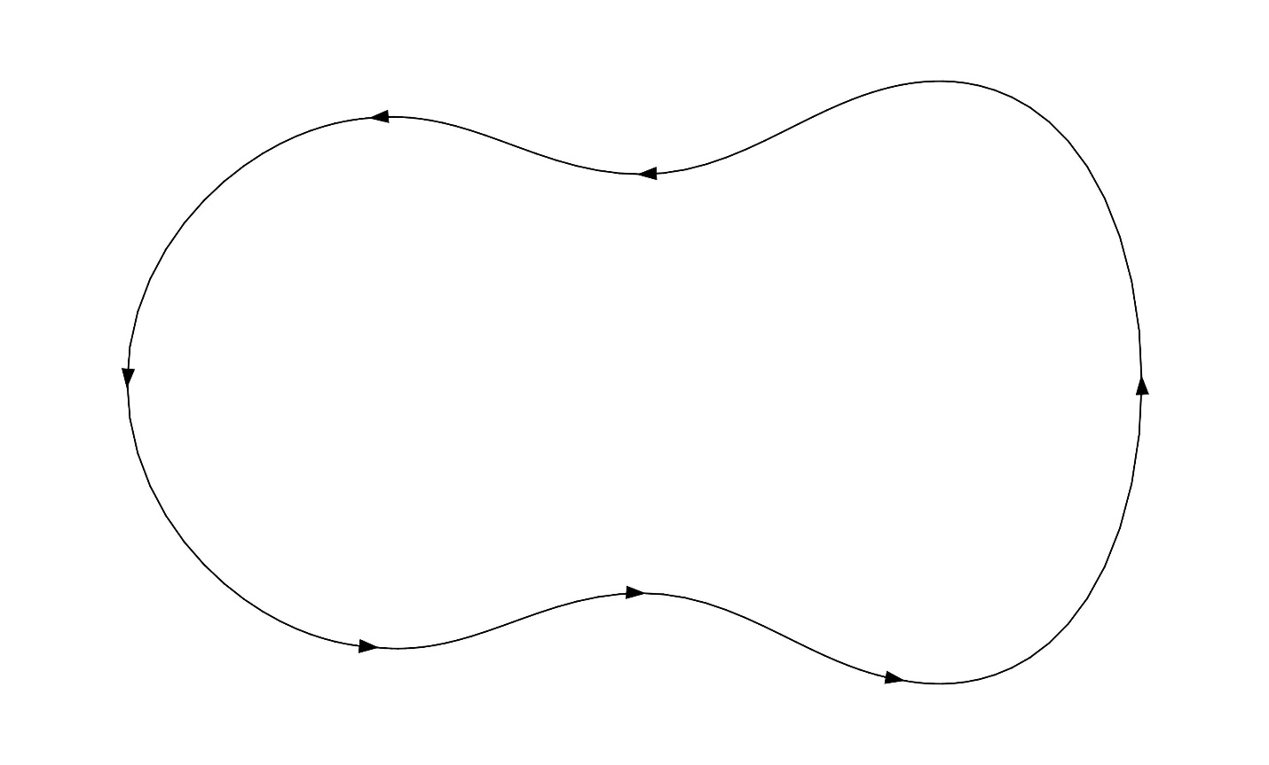

7. Asymmetric Closed Curves
# Source: AI Source: Provided by: [Data Path: Persons Table -> ID Column: 1, Name_En Column: Motasem Essam] -> From: [ChatGPT] on [7/25/2026]
An asymmetric closed curve is a closed curve without a recognizable line of reflectional symmetry or other regular symmetry.
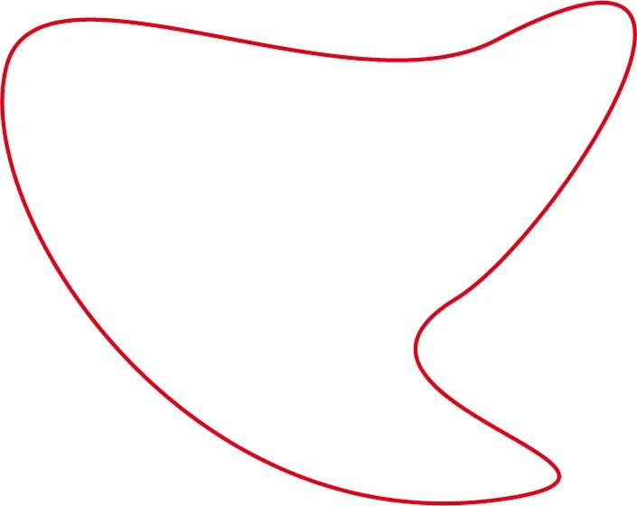
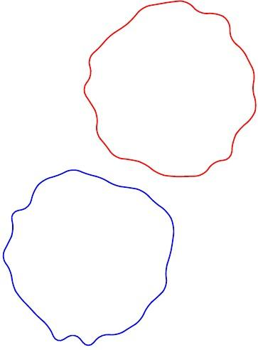
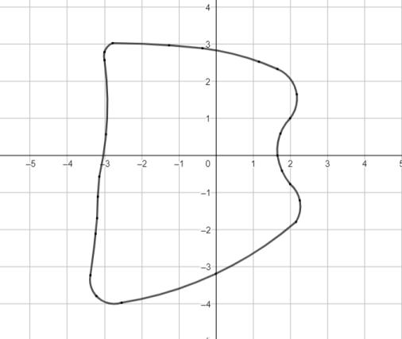

8. Symmetric Closed Curves
# Source: AI Source: Provided by: [Data Path: Persons Table -> ID Column: 1, Name_En Column: Motasem Essam] -> From: [ChatGPT] on [7/25/2026]
A symmetric closed curve has a recognizable symmetry, such as reflectional or rotational symmetry.
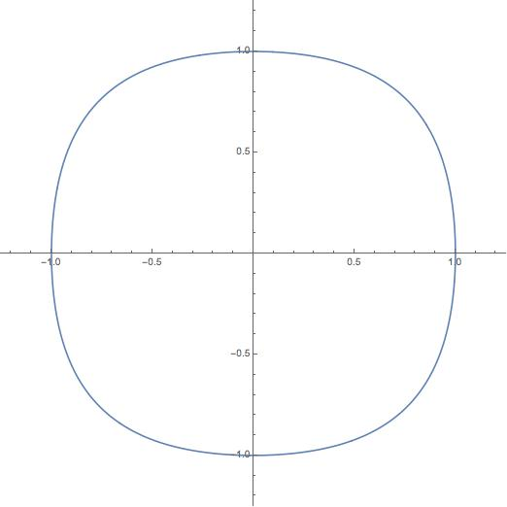
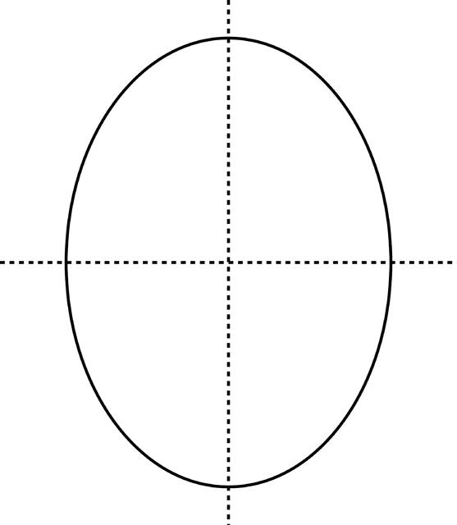
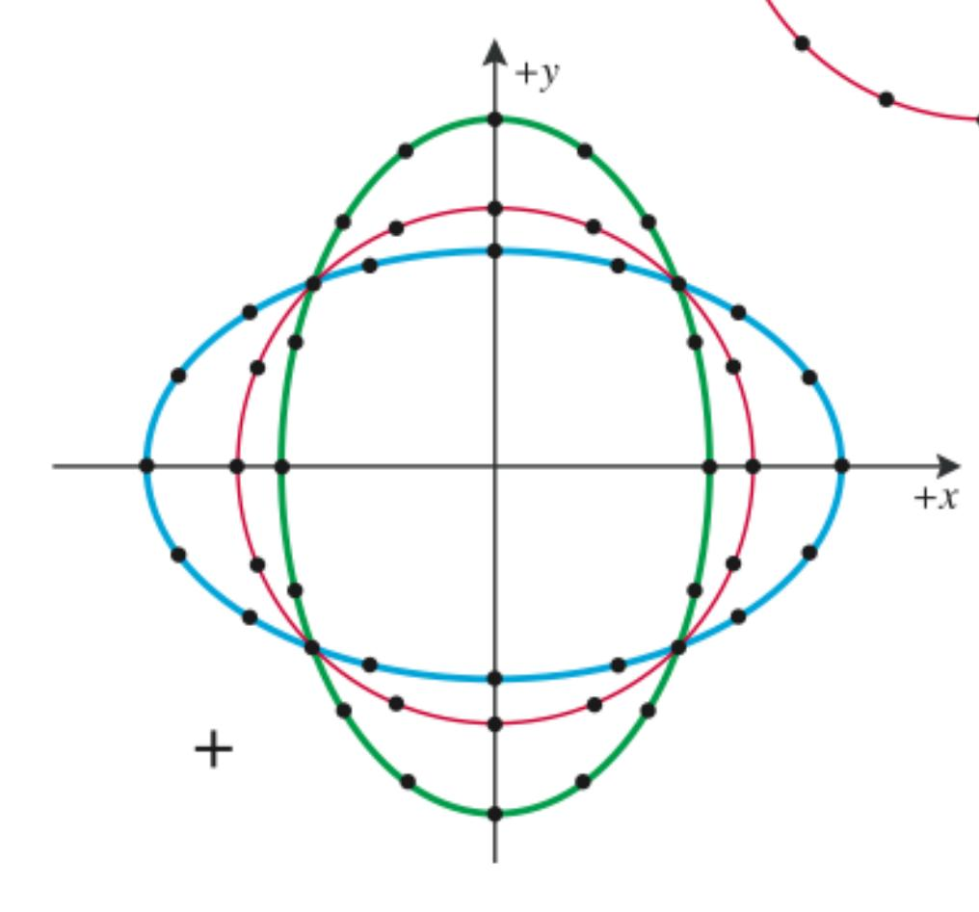
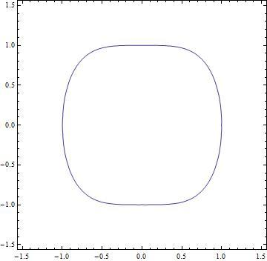

9. Irregular Closed Curves
An irregular closed curve has a closed boundary with changing curvature and no regular geometric pattern.
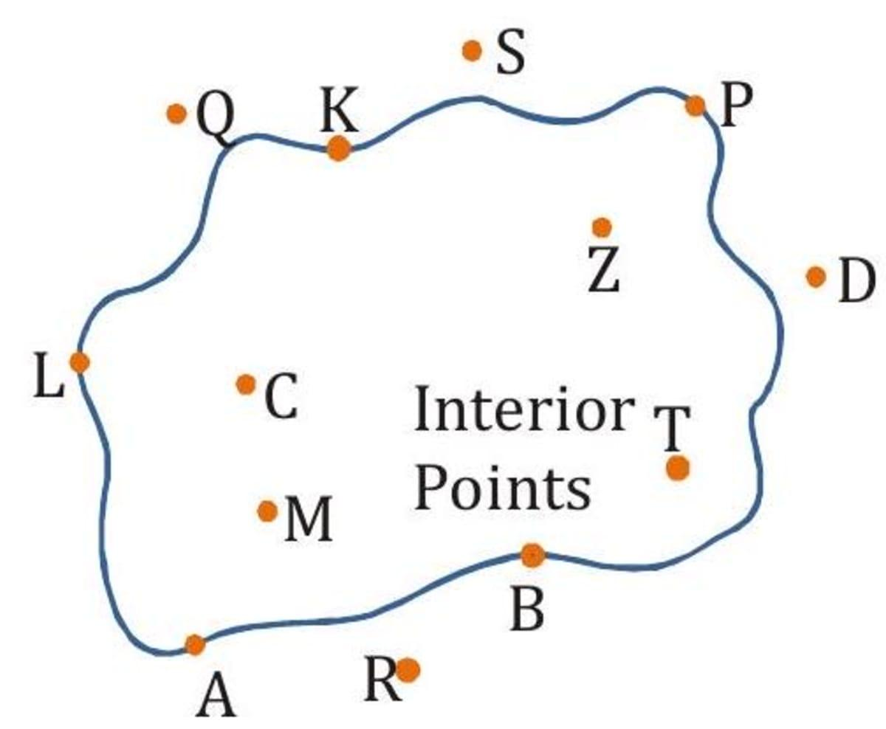
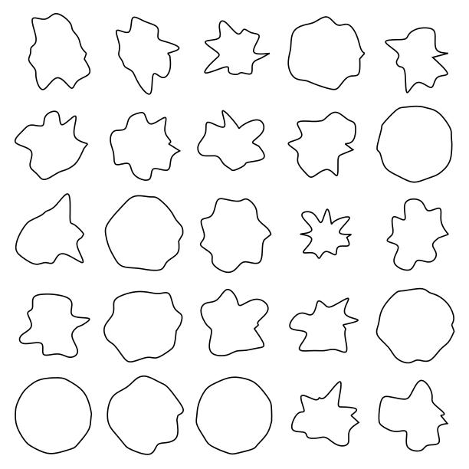

10. Convex Closed Curves
# Source: AI Source: Provided by: [Data Path: Persons Table -> ID Column: 1, Name_En Column: Motasem Essam] -> From: [ChatGPT] on [7/25/2026]
A convex closed curve bends outward without inward indentations.
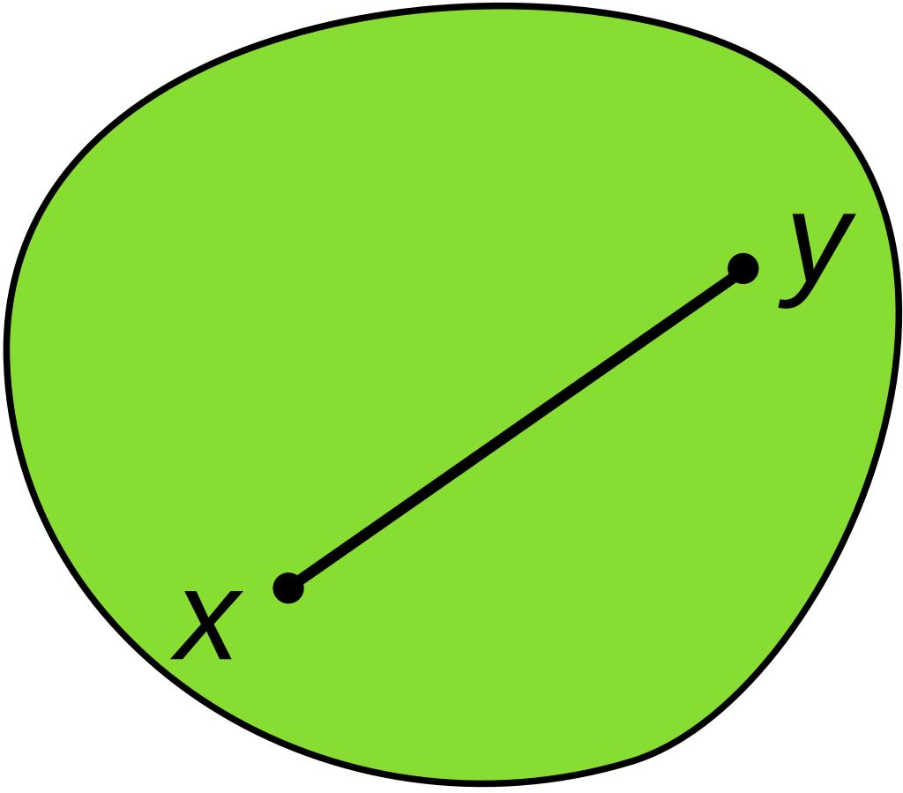
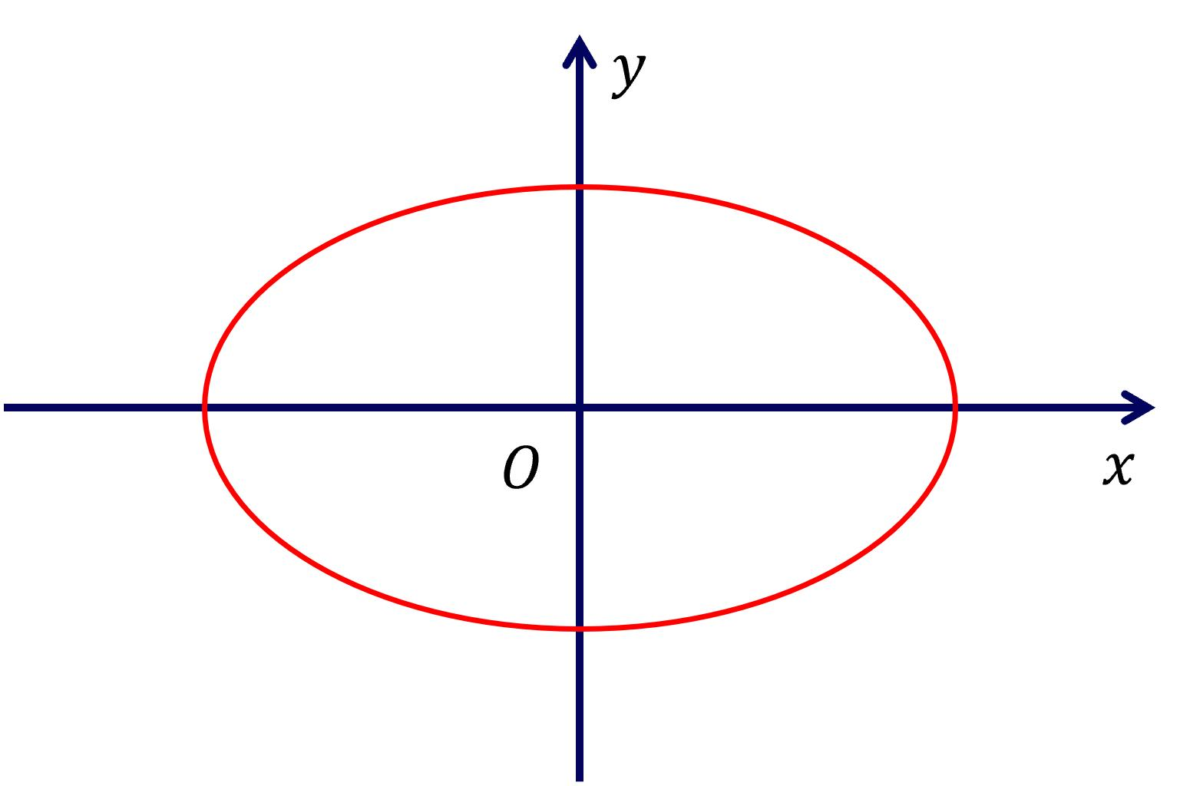
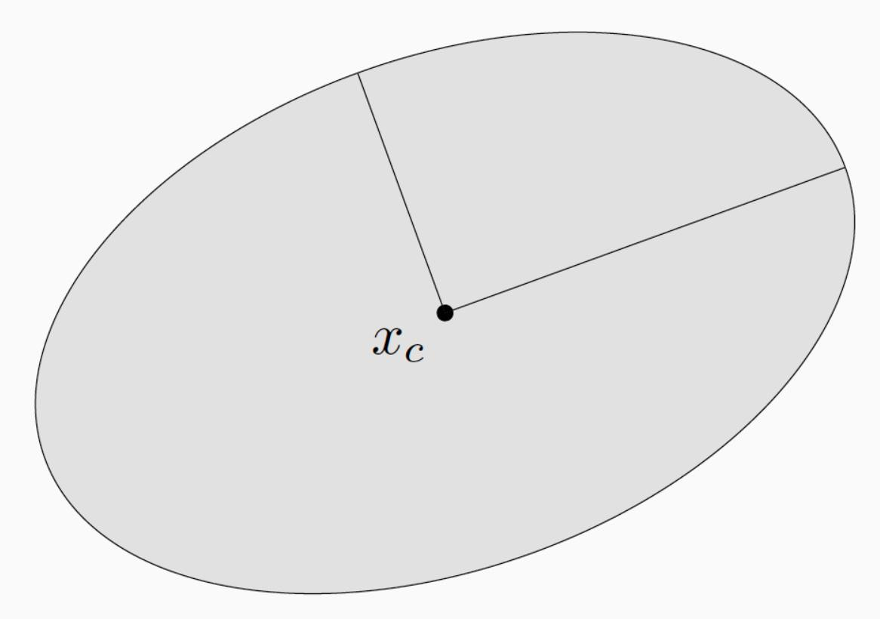
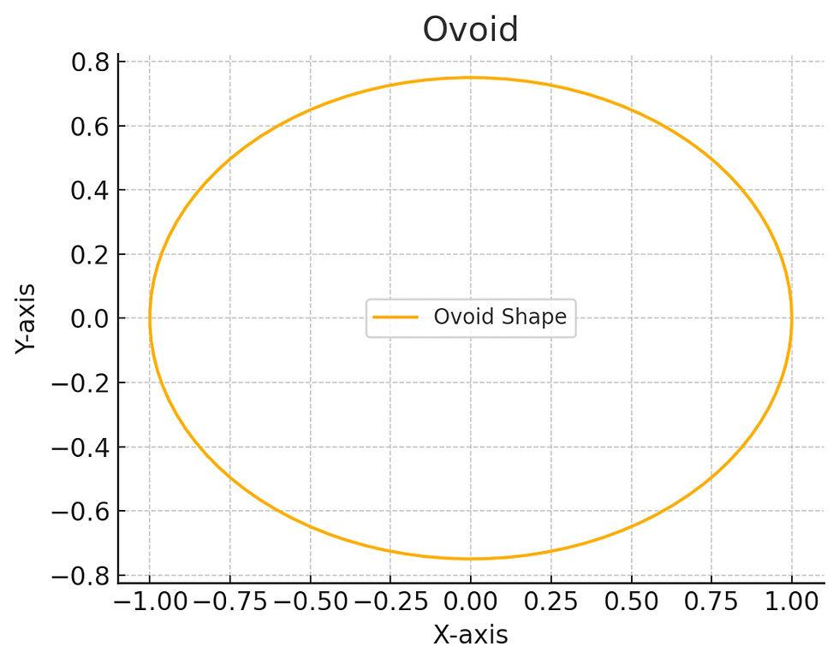
A line segment connecting any two points inside the boundary remains inside the enclosed region.

11. Concave Closed Curves
# Source: AI Source: Provided by: [Data Path: Persons Table -> ID Column: 1, Name_En Column: Motasem Essam] -> From: [ChatGPT] on [7/25/2026]
A concave closed curve has at least one inward indentation.
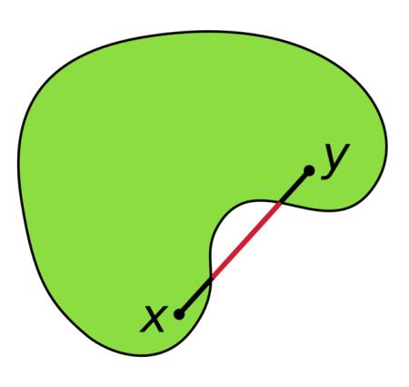
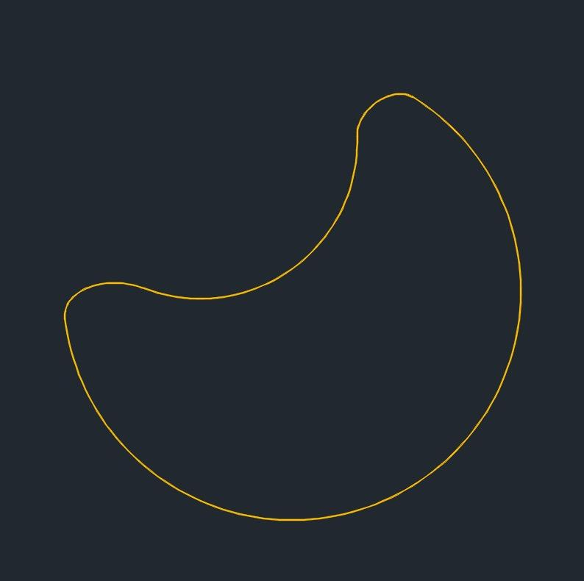

12. Self-Intersecting Closed Curves
# Source: AI Source: Provided by: [Data Path: Persons Table -> ID Column: 1, Name_En Column: Motasem Essam] -> From: [ChatGPT] on [7/25/2026]
A self-intersecting closed curve returns to its starting point but crosses itself one or more times.
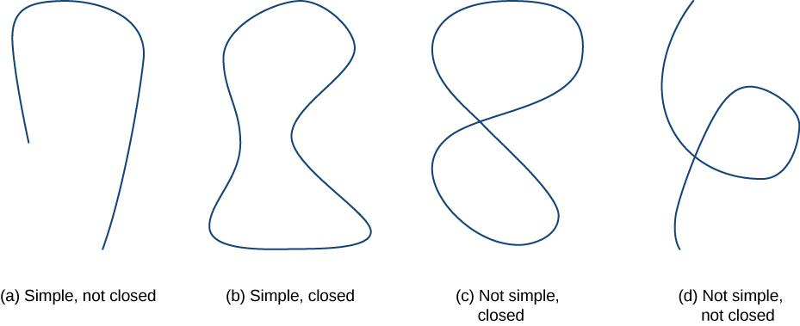
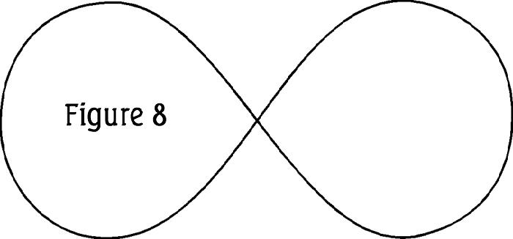
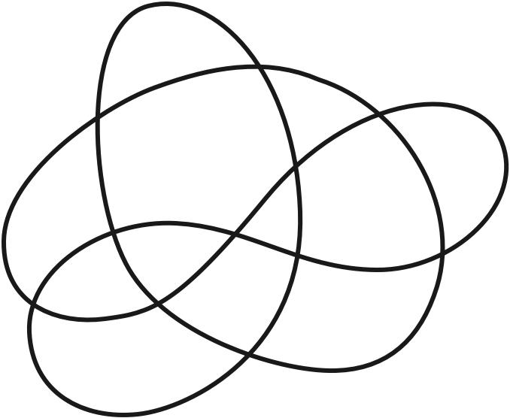
Examples include figure-eight-like closed curves and more complex looping curves.

Classification Table
# Source: AI Source: Provided by: [Data Path: Persons Table -> ID Column: 1, Name_En Column: Motasem Essam] -> From: [ChatGPT] on [7/25/2026]
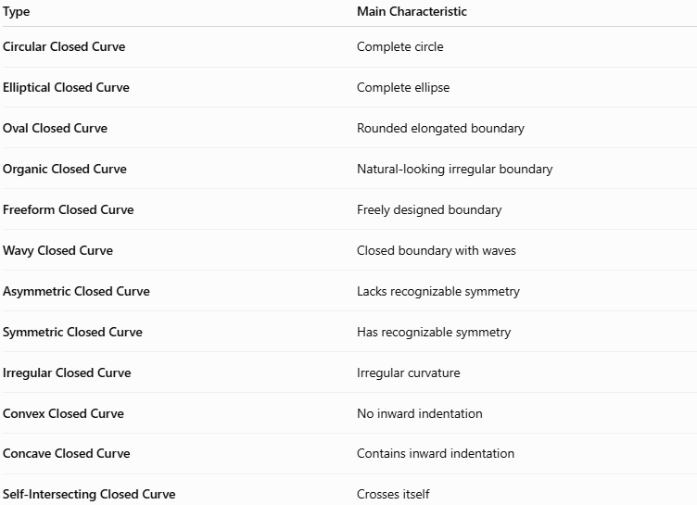
Type | Main Characteristic
Circular Closed Curve | Complete circle
Elliptical Closed Curve | Complete ellipse
Oval Closed Curve | Rounded elongated boundary
Organic Closed Curve | Natural-looking irregular boundary
Freeform Closed Curve | Freely designed boundary
Wavy Closed Curve | Closed boundary with waves
Asymmetric Closed Curve | Lacks recognizable symmetry
Symmetric Closed Curve | Has recognizable symmetry
Irregular Closed Curve | Irregular curvature
Convex Closed Curve | No inward indentation
Concave Closed Curve | Contains inward indentation
Self-Intersecting Closed Curve | Crosses itself

Key Points
# Source: AI Source: Provided by: [Data Path: Persons Table -> ID Column: 1, Name_En Column: Motasem Essam] -> From: [ChatGPT] on [7/25/2026]
A Closed Curve:
$$\boxed{\text{Closed Curve}=\text{Continuous Curved Boundary}+\text{No Endpoints}}$$
It:
- Returns to its starting point.
- Has no endpoints.
- Forms a closed boundary.
- Usually encloses a region.
- Can be regular or irregular.
- Can be symmetric or asymmetric.
- Can be convex, concave, or self-intersecting.
- Can follow a standard mathematical form or be completely freeform.

Conclusion
# Source: AI Source: Provided by: [Data Path: Persons Table -> ID Column: 1, Name_En Column: Motasem Essam] -> From: [ChatGPT] on [7/25/2026]
Closed Curves are curves that return to their starting point, creating a continuous closed boundary with no endpoints. They can be classified by their geometric form, symmetry, regularity, convexity, and self-intersection.
The main types include circular, elliptical, oval, organic, freeform, wavy, symmetric, asymmetric, irregular, convex, concave, and self-intersecting closed curves.

